**Project title:**

**Centralized Web-Based Student Club Management System for KMIT**

**Abstract:**

This project aims to develop a unified, web-based platform to efficiently manage and monitor all student club activities at KMIT. Currently, information such as club registrations, member records, event details, and meeting minutes are fragmented across multiple formats—emails, spreadsheets, and paper files—leading to difficulties in accessing data, ensuring compliance, and presenting organized records during audits or inspections.

The proposed system addresses these challenges by offering a centralized, real-time solution that consolidates all club-related operations under one hub. The platform will facilitate seamless interaction among students, club leaders, faculty coordinators, and administrators. Students will be able to discover clubs, apply for memberships, and participate in events. Club leaders can assign roles, plan events, and maintain documentation, while administrators can monitor compliance, approve activities, and generate reports for accreditation purposes.

The system promotes transparency, simplifies workflows, ensures better documentation, and enhances the overall student engagement experience. Built using modern web technologies and cloud-based storage, the solution is designed to be scalable, secure, and accessible across devices.

**Functional Requirements:**

* **FR1:** Allow students to register and explore clubs.
* **FR2:** Enable club heads to add/edit/delete events, members, and roles.
* **FR3:** Maintain digital records of club activities and documents.
* **FR4:** Provide approval workflows for events and budgets.
* **FR5:** Upload and view event photos, minutes, and reports.
* **FR6:** Enable admin dashboard for monitoring and analytics.

**Non-Functional Requirements:**

* **NFR1:** Secure authentication and role-based access control.
* **NFR2:** Scalable backend to handle multiple clubs and users concurrently.
* **NFR3:** Mobile and desktop responsive UI.
* **NFR4:** Data encryption for sensitive documents.
* **NFR5:** Real-time updates with minimal latency (<2s for key operations).

**User Identification:**

**Student User:**

* View club details
* Request membership
* RSVP for events
* View gallery and documents

**Club Coordinator (Leader/Faculty):**

* Manage member lists and roles
* Add/update event data
* Upload minutes, reports, and images
* Track participation metrics

**Administrator:**

* Approve events, budgets
* Access audit-ready reports
* View club activity dashboard
* Manage compliance

**Workflow of Each User:**

**Student:**

* Logs in → Browses club list → Requests to join a club
* Views upcoming events → Participates/RSVPs → Views event photos

**Club Head:**

* Logs in → Updates club member list
* Adds new event → Uploads documents (minutes, photos, reports)
* Assigns roles → Sends for faculty/admin approval

**Administrator:**

* Logs in → Reviews event/budget requests
* Approves/rejects requests → Monitors overall club engagement metrics
* Generates reports for NAAC/NBA or inspection needs

**Use Case Diagram:**

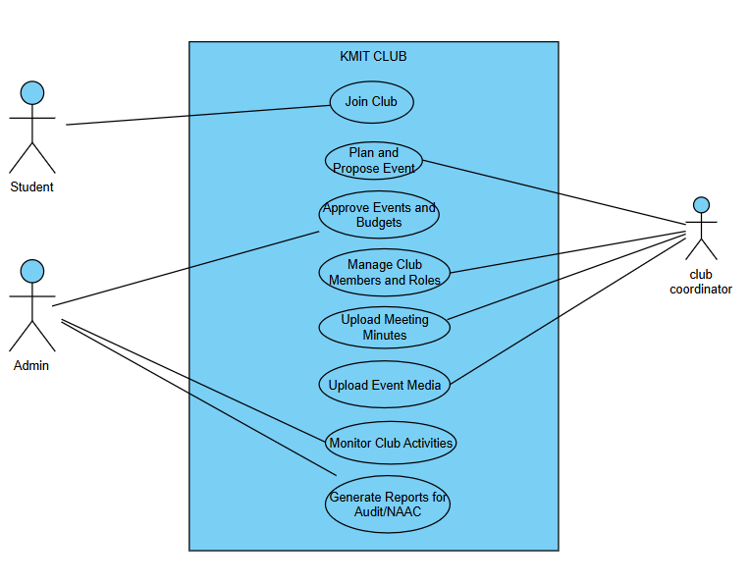

**Installation of Git, starUML, GitAccount screen shots**

